Darkwatch.org Community & Word of Mouth Program
Statistics Report: April 2005

Snapshot of Campaign
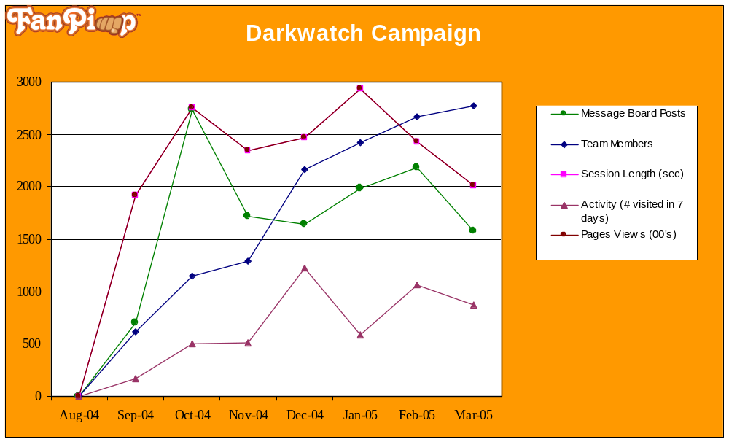

Monthly Overview

- The demo, made available through the PS2 and Xbox demos, was well-received, especially at the New York City gathering which involved over a dozen excited members. Darkwatch-based challenges (including which member could complete the demo fastest) were a huge success. See Challenge Report #52 for additional details.

- The fan fiction challenge proved to be incredibly popular amongst the members, as they all had ideas on where the story should go. Twenty-five pieces of fan art were created, with the best ones displayed on the DW.org homepage. See Challenge Report #45 for additional details.

- The Demons versus Agents recruitment challenge resulted in 100 new members being recruited to the community. It also generated a great deal of positive energy on the site as members formed ties to their sub-groups. See Challenge Report #47 for additional details.

- A GameSpot Union was established by the Community. A challenge was created in which community members applied to be the Union Leader. From the member submissions, we selected the leader and a handful of officers. The Union currently includes 31 members and 8 officers. It has completed 25% of Level I and currently has nearly 200 DW related posts on its message board. See Challenge Report #48 for additional details.

- The members’ chat on April 1st was incredibly popular, with about 30 members participating. Through the chat, members generated the developer questions, later made available to members as an exclusive Q &A.

- The first community survey was completed on April 1st. There were a total of 409 responses. The purpose was to assess the demographic and behavioral characteristics and the brand awareness levels of the community’s most active constituents. See survey results for additional details.

Community: Membership Growth
Total Team Members:  3,016 | Recruitment
Total Team Members:  3,016 | New Members / Week: | 84.12
Total Team Members:  3,016 | % from Member Invites: | 88.06%
Total Team Members:  3,016 | % from Other: | 11.94%
Total Team Members:  3,016 | Activity
Total Team Members:  3,016 | % of Members Visited in Last 7 Days: | 29.44%

Community: Cumulative Membership Demographics
By Gender | By Age
 | 
By Country (top 10) | By State/ Prov. (top 10)
  Country | Total | %
  United States | 1867 | 61.99
  Canada | 886 | 29.42
  United Kingdom | 52 | 1.73
  Australia | 15 | 0.50
  India | 11 | 0.37
  Netherlands | 10 | 0.33
  France | 9 | 0.30
  Belgium | 7 | 0.23
  Philippines | 7 | 0.23
  Puerto Rico | 7 | 0.23
  State/Prov. | Total | %
  Ontario | 464 | 16.70
  California | 286 | 10.30
  British Columbia | 147 | 5.29
  New York | 127 | 4.57
  Florida | 116 | 4.18
  Texas | 109 | 3.92
  Ohio | 90 | 3.24
  Pennsylvania | 88 | 3.17
  Michigan | 77 | 2.77
  Alberta | 75 | 2.70

Community: Team Activity
 | April Statistics | Cumulative Statistics
Responses to Quizzes: | 520 total response(s) | 4,863 total response(s)
Responses to Polls: | 681 total vote(s) | 6,114 total vote(s)
Audio/Video Links: | 1,433 pieces of content viewed/listened to | 14,622 pieces of content viewed/listened to
Banners/IM Icons: | 37 banners submitted 3 approved  26 icons submitted 1 approved | 456 banners submitted 184 approved  361 icons submitted 159 approved
Message Board: | 108 topics 1,467 posts | 959 topics 14,046 posts

Comparison to Official Site: Web Traffic
 | FP Community Site | Official Site
Time on Site | 10 min, 8 sec | 3 min, 22 sec
Page views | 193,179 | 31,866
Unique visitors | 5,375 | 7,898
Page views per visitor | 35.94 | 4

Viral Marketing: Links Sent/ Posted/ Clicked
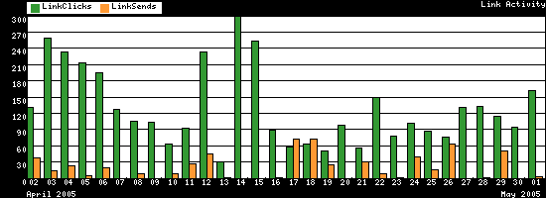
 | IM | Email | Web
Links Sent/Posted: | 13 | 556 | N/A
Links Clicked: | 9 | 367 | 1,152
Click through Percent: | 69.2% | 66% | N/A

Word of Mouth: Referring Sites
Website | Category | Referred | % of Total Referred
http://www.highmoonstudios.com | Official Site | 546 | 7.21%
http://www.comicscommunity.com/ | Comics Community | 406 | 5.36%
http://forums.redflagdeals.com | Canadian Site | 245 | 3.24%
http://www.tradegamesnow.com | IGN | 228 | 3.01%
http://chimaira.host.sk/fp.htm | Member Site | 196 | 2.59%
http://www.theshield.com | Official Site | 80 | 1.06%
http://www.rebiohazard.com | Member Site | 65 | 0.86%
http://www.penny-arcade.com | Gamers Comic Site | 30 | 0.40%
http://www.geocities.com/darkphyre024/media.htm | Member Site | 24 | 0.32%
http://www.horrorwatch.com | Horror Website | 20 | 0.26%
Top 10 |  | 1,840 | 24.31%
Total |  | 7,569

Challenge Summaries

Challenge #45: Fan Fiction
Challenge Description: | Agents are encouraged to write fan fictions based on the Darkwatch universe. Entries must be at least 500 words.  Currently: Agents are submitting their works to Fanfiction.net to have them create a “Darkwatch” category. A Darkwatch category will allow for easy publication of future fan fictions and will create a Darkwatch community on this site.
Start/ End Dates: | March 18th – May 18th
Objective:  (Community building, WOM, viral) | Community building: Encourages members to devote time and express their fandom of Darkwatch. Users read other members’ works to enhance the sense of community.  Viral: With the publication of their works, members will be encouraged to send their fan fictions to friends, spreading awareness for the game.
Number of Participants: | 25 pieces of fan fiction were created
Results: | Community Building  - Message board thread features 4 pages of discussion.  - 12 best entries featured on Darkwatch.org  - Best entries submitted to High Moon Studios for comments
Top Submissions: (include team member, description) | Team Member, Revolver:  I faintly heard the shot that sounded out behind me, but a few seconds I found myself flying through the air as my horse stumbled and collapsed below me.
Team Member, Onikage009:

As Jericho approached the cemetery, a thick mist surrounded the area. No normal human being would be able to see an inch past his nose under these conditions, yet Jericho was no normal human being. Using his blood vision ability, he spotted a couple of zombies in the distance.
Team Member, Guardian:

I watched as the flames erupted and limbs flew back towards me, the dying screams of my brethren cut short as they were engulfed in their funeral pyres. Confusion. I swung about, suddenly realizing that we were the ones being ambushed.

Challenge #46: The Inside Scoop
Challenge Description: | We're nosy. We admit it. We want to know all about you.  Take five minutes to fill out our (8 question) survey and tell us a little bit about yourselves. In return, we'll give you a sweet 200 points.
Start/ End Dates: | March 22^{h} – March 29th
Objective:  (Community building, WOM, viral) | Research: Assess demographics of most active community members and awareness for the Darkwatch IP. *Survey respondents for FanPimp campaigns typically tend to be the most active community participants.
Number of Participants: | 411
Results: | Demographics  - 53% of respondents between the ages of 13-24 (which is very similar to what we have seen within the demographics of the entire community)  - 65% of respondents check the site at least once a week  - Respondents average 11 hours a week playing video games and 15 hours a week online  - Respondents other interests include watching movies (80%), surfing internet (68%), hanging out with friends (52%), and reading (48%)  Brand Awareness  - 70% of community list Darkwatch.org (followed closely by Darkwatch.com) as primary source of information on the game  - Before joining Darkwatch 51% of respondents knew nothing about the game. Now, 63% of respondents state that they know a lot about the game.

Challenge #47: Agents Versus Demons
Challenge Description: | Do you like rushing into burning buildings to save screaming babies? Or, do you like burning buildings and eating babies? Choose a team you'd like to be on: Darkwatch Agents or Lazarus' Demons. Then, you will try to convert as many people to become Agents or Demons. The winning team will score tons of points, and honor.  *Dedicated threads were set up for the Agents and Demons teams.
Start/ End Dates: | March 25th – April 5th
Objective:  (Community building, WOM, viral) | Community Building: Create groups within the community to facilitate relationship building and heighten sense of friendly competition. The groups formed during this challenge will be used for future challenge.  WOM for the community: Members are encouraged to recruit other community members.
Number of Participants: | 120+ (~60 members for the Demons Team and 60 for the Agents Team)
Results: | Community Building  - Message board threads feature 8 pages of discussion, across three threads.  WOM for the Community  - 100 members recruited, 91% from member referrals.

Challenge #48: Union Leader
Challenge Description: | So we went on GameSpot the other day and noticed everyone has a union: Halo, Resident Evil, Mario, etc. But somehow we don’t. We can kill the undead but we haven’t yet been able to set up a Union? Well now, we’ve decided that it’s high time we have a union and it is going to be the hottest thing out there. So what do we need to get the Darkwatch union going? First of all, we need a dedicated leader. Requirements: to be a leader of a Union on Gamespot, you need to be a Gamespot complete member or a level 6 member.  Do you meet the criteria? To apply, create a “Union Leaders” resume—list your skills and your vision for the site (why would you be the right person for such an ambitious task?) Impress us and you’ll get the job. Starting salary: 1000 points/ month.  *As the launch date of the Union approached, a news item was posted to generate excitement within the community.
Start/ End Dates: | March 29th – April 12th
Objective:  (Community building, WOM, viral) | Word of Mouth: Create a GameSpot Union to create additional awareness for the game.
Number of Participants: | 39
Results: | Word of Mouth  - GameSpot Union has 8 officers and 31 members.  - Union has achieved 25% of Level 1  - Union has earned Platoon and First Emblems  - Union currently 24 threads and nearly 200 posts  - Six articles have been posted
Top Submissions: (include team member, description) | The selected GameSpot Union Leader (Castorz)  I would like to be the creator of the Darkwatch Union at Gamespot. I am at level 7 over there but I have been visiting the website for several years. I know exactly how everything works and I also have a lot of contacts in order to recruit people into the Union. I am a very dedicated person and I would take time off my schedule each and every day in order to update the message boards/news/announcements. I am really looking forward to Darkwatch. I would make sure that it is great to look at since High Moon developers might check it out from time to time
Union Member, Revolver’s article:

Darkwatch seems to be the first game to use a new time frame and be seriously committed to also be an equal among the established giants. A bloody romp through a vampire infested Wild West, Darkwatch allows the player to use weapons that bend the limits of plausibility. From steam powered gatling guns to four-barreled shotguns that redefine the term "quad damage," Darkwatch is intent on separating itself from the plethora of generic shooters.

Challenge #50: Sunday Chat
Challenge Description: | Have a question that's been burning in your heart? Stop by the Chat Room this Sunday, April 3rd at 5PM EST and ask Andrew about anything Darkwatch and game-related. If you have some really important questions, Andrew will pass them directly to a Producer of the game.
Start/ End Dates: | April 3rd
Objective:  (Community building, WOM, viral) | Community Building: Encourage active discussion in the community and give the community the opportunity to ask the developers questions
Number of Participants: | 20+
Results: | Community Building  - Questions were sent to the developers and the resulting exclusive Q&A was  posted on Darkwatch.org.
Top Submissions: (include team member, description) | Sample Questions:  How does co-op mode in the PS2 version work? Are both players Jericho?  How has the Darkwatch community influenced the development team?  What presence will High Moon have at this year’s E3?
Excerpt:

What plans are there for cross-promotional merchandise, like comics, toys, etc.? (Shawn_Solo)
Good question! You’ve noticed that Darkwatch lends itself to more than just video games. This is entirely by design, since from the very beginning the developers set out to create a universe, not just a game premise. They’ve already experimented with expanding into literature with a graphic novel coming out in Heavy Metal magazine’s June issue (should be on newsstands May 10th). We’ve also explored a Darkwatch film, meeting with interested Hollywood scriptwriters. This was top secret until someone leaked it to a Hollywood rag at last year’s E3, so there you have it. Ultimately where we go with these ideas, merchandise like toys and action figures included, is dependent on the success of the game. One thing for sure is our creative minds are at the ready with plenty of ideas. To see what I mean, check out ‘Darkwatch Through the Ages’ in our Heavy Metal story.

Member Responses:

Great questions guys! Great answers as well; all of it is interesting to read through.
Very Awesome!

Challenge #51: Comic
Challenge Description: | You asked for it, and you finally got it! Prepare yourself to make a Darkwatch comic. It can be funny, it can be dramatic-- as long as it's about Darkwatch. Submit your entry in the Offline Tasks section and you can earn up to 500 points (more or less depending on how awesome your comic is).
Start/ End Dates: | April 5th – April 26th
Objective:  (Community building, WOM, viral) | Community Building: Encourages members to use their artistic skills to talk about Darkwatch.  Viral: Members that use Gnomz have their comics featured on the site with tools which allow for easy distribution. Plans to distribute top tier fan art will be incorporated into a future challenge.
Number of Participants: | 40
Results: | Community Building  - 4 pages (over 49 posts) were generated on the message board.  Viral  - A number of exceptional artists have been discovered on Darkwatch. Their talents can be used for future word of mouth or Viral campaigns.
Top Submissions: (include team member, description) | Team Member, MJC’s Submission:  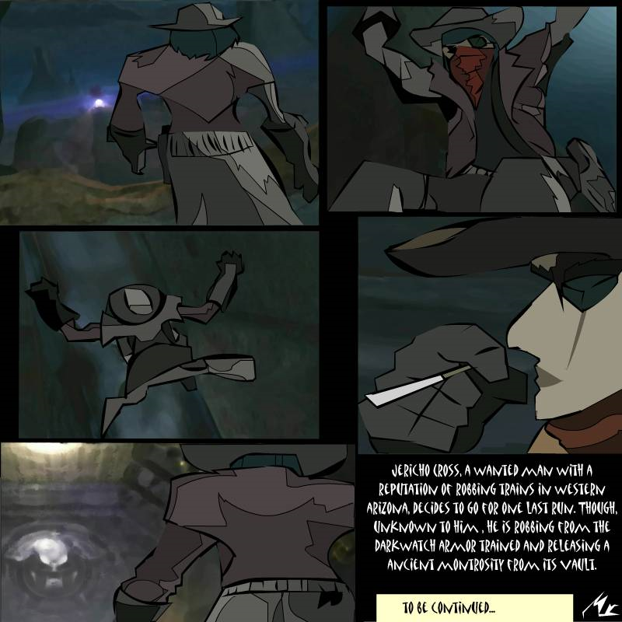
Team Member , Howler36’s Submission:

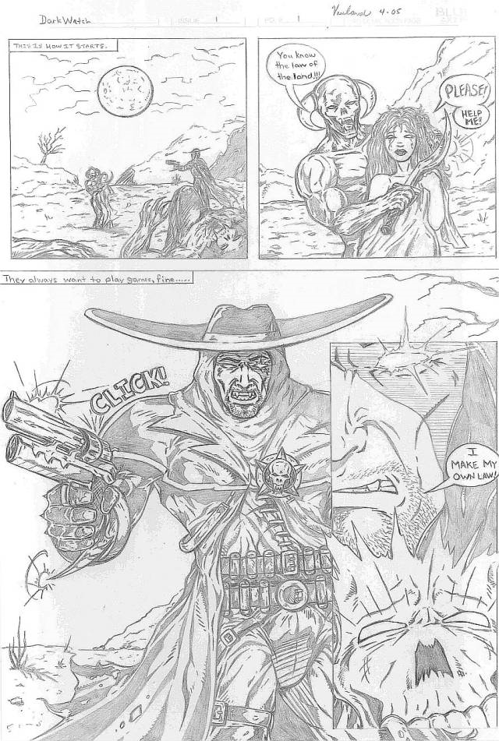

Challenge #52: Darkwatch NYC Party
Challenge Description: | If you want to play the demo, meet some of your fellow agents, and yell at Andrew, here's your chance! We're going to be having a party from 6pm to 8 PM in Lower Manhattan on Friday, April 22nd. Pizza and soda will be plentiful and hopefully, we'll even have some DW T-shirts to give out. If you can make it, just hit the submit button and send us your email address. Space is limited so reply quickly!
Start/ End Dates: | April 22nd
Objective:  (Community building, WOM, viral) | Community Building: Allow members to meet one another and play the DW demo  Word of Mouth: Generate word of mouth for the game and the community.
Number of Participants: | 15
Results: | Community Building  - A dozen people indulged in pizza and the Darkwatch demo, with T-shirts and badges being given away for DW related accomplishments (such as completing the demo in the least amount of time)  Word of Mouth  - A number of outsiders expressed interest in the game and the community as a result of watching the members play and playing it themselves.
Top Submissions: (include team member, description) | 
 | 

